SAP 4HANA Overview

What Is a Data Warehouse?
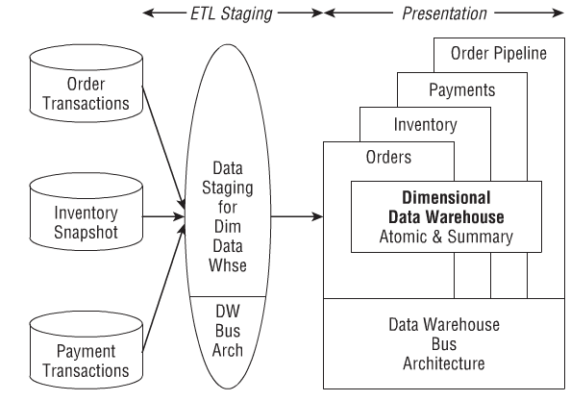
DW basis of BI; OLAP, analytical processing.
Get data, put through data staging, put into data warehouse
Staging is ETL
Bus Architecture?

Reference Architectures
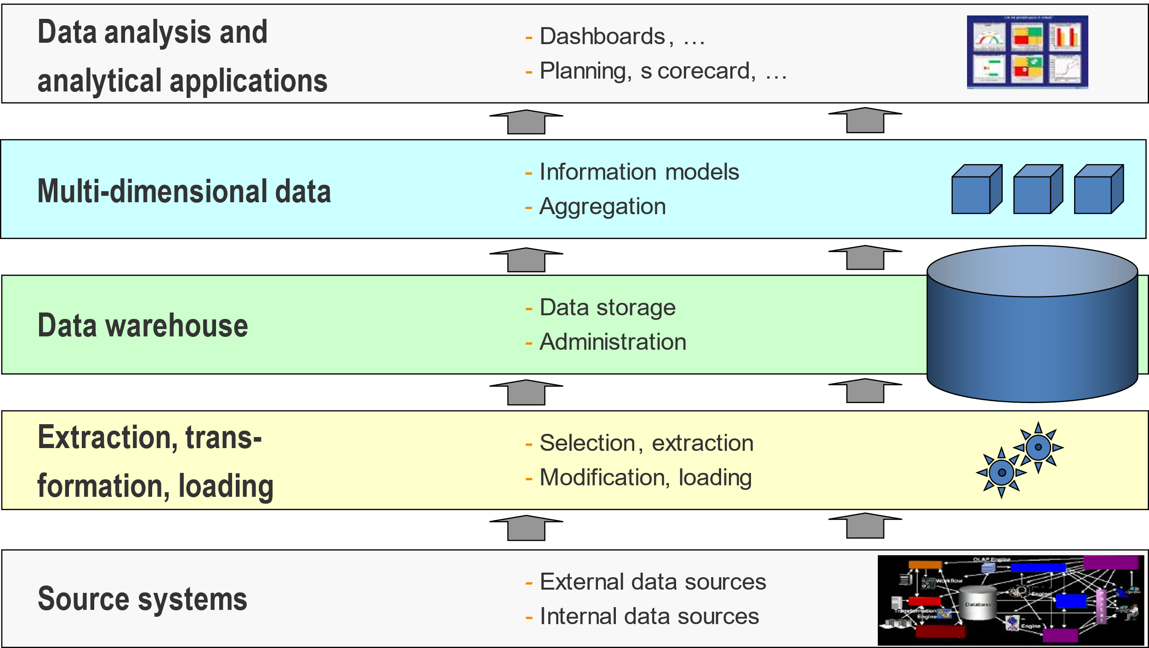
Data exists in sources
Data pulled from source, initiate ETL
ETL pulls into the data warehouse
DW becomes multidimensional data?
Data brought in for analysis

If aggregated historical data needed, may set up an addtl data warehouse.
If need curent operational data, implement ODS
SAP Evolution
SAP ERP -> SAP S/4 HANA
SAP BW -> SAP BW/4HANA
SAP Analytics -> SAP Predictive Analytics with HANA
SAP Cloud/4HANA

In-memory Appliance Development
Large amt of RAM
Persistent Memory (PMEM)
Data retained during power outage
Cheaper than DRAM (Dynamic Random Access Memory)
Available in much larger size
HANA (High-Performance Analytic Appliance) natively uses PMEM alongside DRAM
Can have up to 128 TB of memory
Possible to store entire database in memory
Factors that enable in-memory database in SAP HANA
Huge amnts of memory
Auto data compression
Data tiering
Hot data stored in-memory
Warm data stored on disk

Persistent Memory (PMEM)
Lower latency for data access compared to disk access
SAP BW/4HANA Architecture
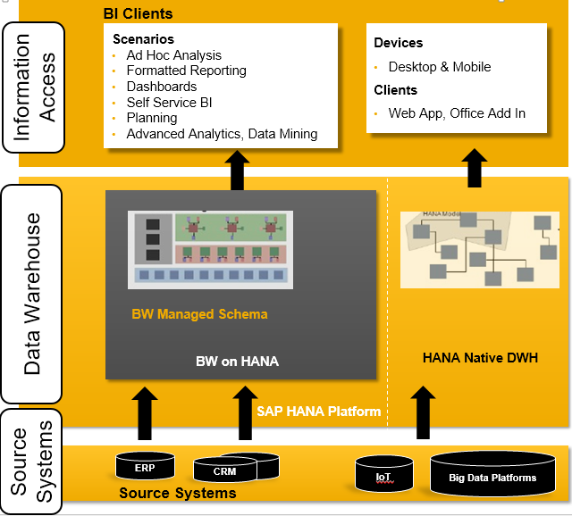
Data Sources pool into BW HANA
BW HANA leads to BI clients

SAP Business Intelligence Platform
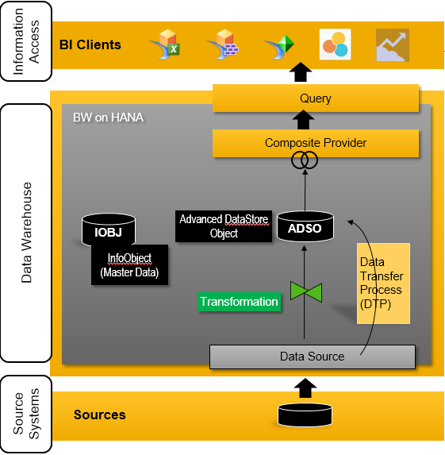
Data sources pool into data source objects via DTP
Extract data, transform it for the aDSO, then load it into CompProvider?
Dta loaded into infoobjects and adso
Adso leads to composite provider
Composite provider gets queried
Query useable in BI clients

SAP BW/4HANA Objects
Data Source
SAP internal representation of external data
Modeling objects
InfoObjects – manage master data
Open ODS views – Data virtualization
Advanced Data Source Objects (aDSOs) – Data persistency
CompositeProviders – Logical layer
InfoObjects
Smallest unit in SAP; used to build data structure, “brick”
Can be viewed as a database field w/ properties
Represent business objects from end-user’s view
Allow storage of master data
Two important types
Characteristics – contextual elements; DIMENSION
Business object
Has a key and a description, latter is language dependent
May have further attributes
Can form hierarchies
Key figures – metrics
KPI; measure documenting business performance
InfoObjects are unique to SAP BW
Characteristic InfoObjects and Key Figure InfoObjects are brought together to reveal FACTS

Open ODS Views (Operational Data Store)
Allow direct data access w/o InfoObjects
Is merely a view of the source object; no data persistence (virtualization)
Pulls in data from external systems

InfoProviders (FACTS)?
Give outside clients access to data records via queries
Provide specific views of data that exists internally

Two main types of InfoProviders
aDSO
Stores data physically; persistency
Consist of InfoObjects and/or ordinary database fields
Three tables: Inbound table (data written here), change log, active data
Reporting done on union of inbound/active tables
Composite Providers
Virtual data; combine data from other InfoProviders for reporting/analysis
Layer that decouples reporting from data storage

High-level Overview

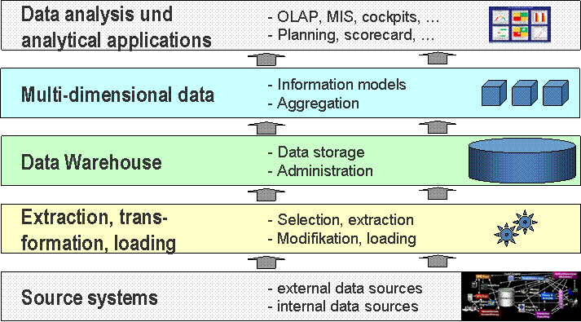

ETL Process
Extraction
Data acquisition; extract from source system; transfer to target via InfoPackage
Put into persistent staging area (PSA); inbound data storage area
Transformation
Data cleaned, consolidated, integrated, and maybe combined from multiple sources
Loading
Data flow control; use InfoPackages for loading data

Data Flows
DataSource – interface object to source system representing source data structure
Transformation – Transforms data according to assigned rules
DTP – Triggers data transfer
Process Chain – Set of processes triggered in a specific order
